**Camera Deployment Best Practices for Streamflow Monitoring   
Using Computer Vision Machine Learning**

October 2019

To collect consistent and representative photo data for the Regional-State Innovation Streamflow Monitoring Project, this best practice document will outline guidelines for camera deployment and data collection. Partners can also send in previous photos and hydrological data if collected according to the QAPP and this Best Practices document so they meet acceptable image and flow data criteria.

**Camera Deployment:**

Using the criteria laid out in the decision tree (Figure 1), select at least one stream site to deploy a game camera to continuously record photos. Select a reach that best represents that stream’s typical flow regime. The camera and hydrological equipment should be in the same stream segment, that is, not separated by a tributary. It's fine if they are in different micro-habitats. Bankful images are preferred and more useful at this point than staff gage photos. If you are interested in a specific location and it is difficult to get bankful images, the staff gages images will still be useful.

Record the following metadata to submit with the photos:

*Required*

1. site ID
2. timezone offset (e.g. -4 hours for Eastern Daylight Time), which will be used to convert the timestamps of the individual images to UTC.
3. Latitude and longitude

*Optional*

1. camera ID using custom key-value pairs (e.g. CAMERA_ID=001)

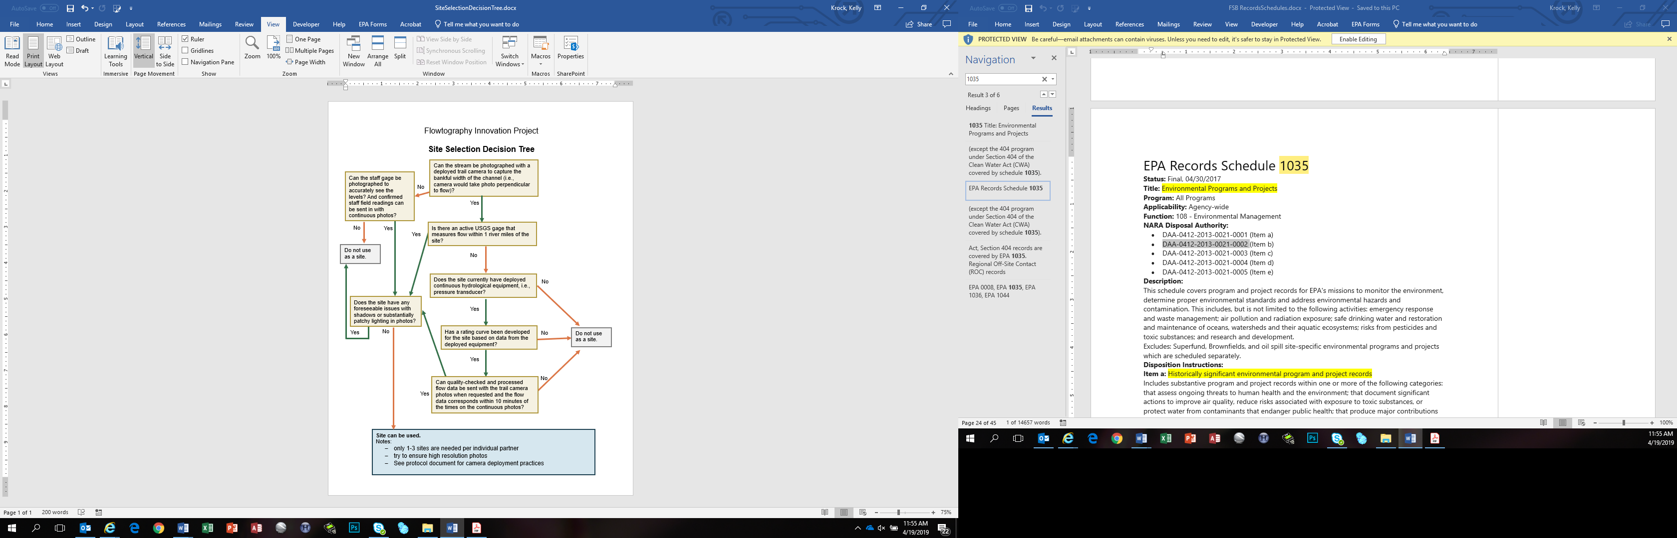**Figure 1:**  Stream Site Location Decision Tree.

Once a suitable site is selected, set up the camera with the following guidelines (see Figure 2 and Figure 3):

* Photos should be collected every hour, as close to the hour (i.e., XX:00), as possible.
* The photo composition should contain at least 2/3 of the stream in the image (less than 1/3 forest or other background) and is best achieved by orienting the camera downwards toward the stream surface.
* The camera should be oriented to take photos looking upstream and capturing the bankfull width of the stream.
* Exposed rocks are valuable in the image to aid the computer algorithm development.
* An ideal shot would also contain a view of a riffle-pool-riffle sequence but not required due to potential difficulty in positioning and logistics.

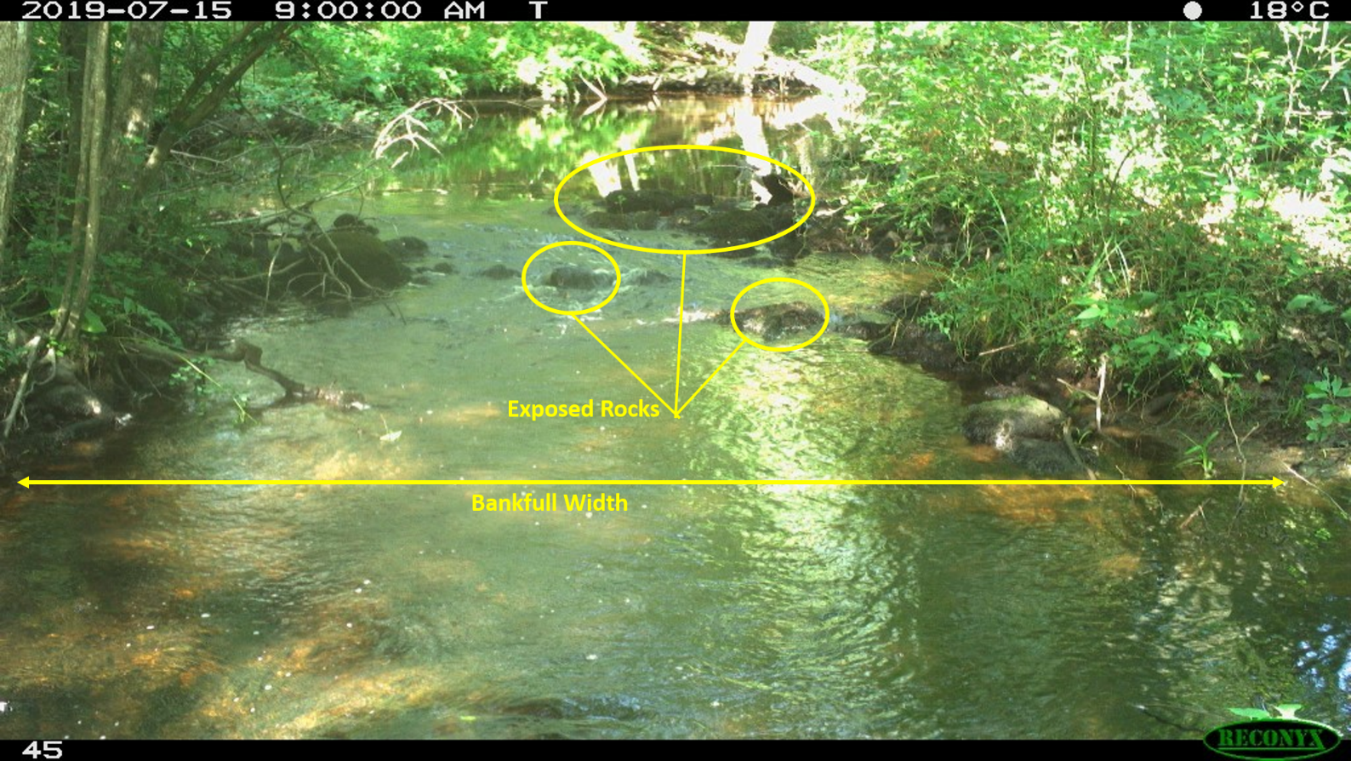**Figure 2:** Example photo showing bankfull width and some exposed rocks. (Source: CTDEEP;

Pendleton Hill Brook)

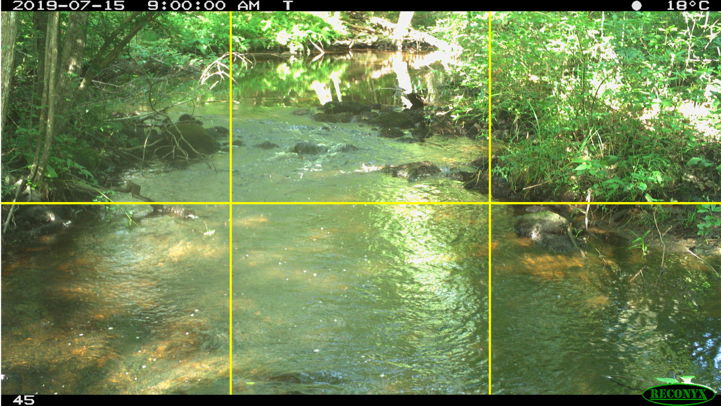

**Figure 3:** Example photo showing roughly 2/3 stream and 1/3 habitat. (Source: CTDEEP;

Pendleton Hill Brook)

**Description of Moultrie Camera Setup:** Use CTDEEP’s SOP for Setting Moultrie Trail Camera (saved on project SharePoint site https://usepa.sharepoint.com/sites/R3_Work/flowtography/).

**Description of Reconyx Camera Setup:**

**Camera Maintenance:**

After every check and download, orient game cameras in the same way to the best of your ability.

Clean the cameras upon regular field checks as needed by wiping the lens with a scratch-proof wipe and removing any other debris from the housing.

Replace any cameras with moisture inside or other damage.

Retain any field notes if needed to QA data or answer any questions on anomalies or other issues.

**Hydrological Data:**

Hydrological data, either from deployed equipment or a USGS gage, must be collected in addition to the photos. If applicable, set hydrological equipment to record every 30 minutes on the hour and half hour.

Collected hydrological data, either from a USGS gage station, or equipment deployed according to Regional Monitoring Network wadeable stream methods (U.S. EPA 2014). Deployed equipment will be held to the quality criteria outlined in the Generic Quality Assurance Plan For Monitoring Networks to Document Long-Term Conditions and Detect Changes in High Quality Wadeable Streams (EPA/600/R-16/034) (both saved on project SharePoint site <https://usepa.sharepoint.com/sites/R3_Work/flowtography/>).

If using data from a USGS gage, USGS’s website notes on the stream gage’s page when data are provisional and subject to revision until they have been thoroughly reviewed and received final approval. USGS’s website also may indicate data quality for periods of time or certain parameters in the site’s “Remarks”. Note in metadata upon data submission if the data is marked as provisional or has other QA notes on the USGS website. Additional follow-up to the website should occur to determine if there are any data changes once the data is verified.

**Data Submission:**

## When ready to submit photos and hydrological data, ensure data is complete and accurate before sending in for integration into the website. Database Specification and Upload Workflow for the USGS Flow Photo Explorer are on the SharePoint site at: <https://usepa.sharepoint.com/:w:/r/sites/R3_Work/flowtography/Shared%20Documents/Protocols%20%26%20QAPP/USGS%20FPE%20-%20Database%20Specification%20and%20Upload%20Workflow%20%20-%2020190815%20(preliminary).docx?d=wc04e571ac38f49eea962c14287509cce&csf=1>.